CNT Stone-Wales Transition State Optimization

Method: PBE/6-31G(d)

Optimized ground state nanotube: 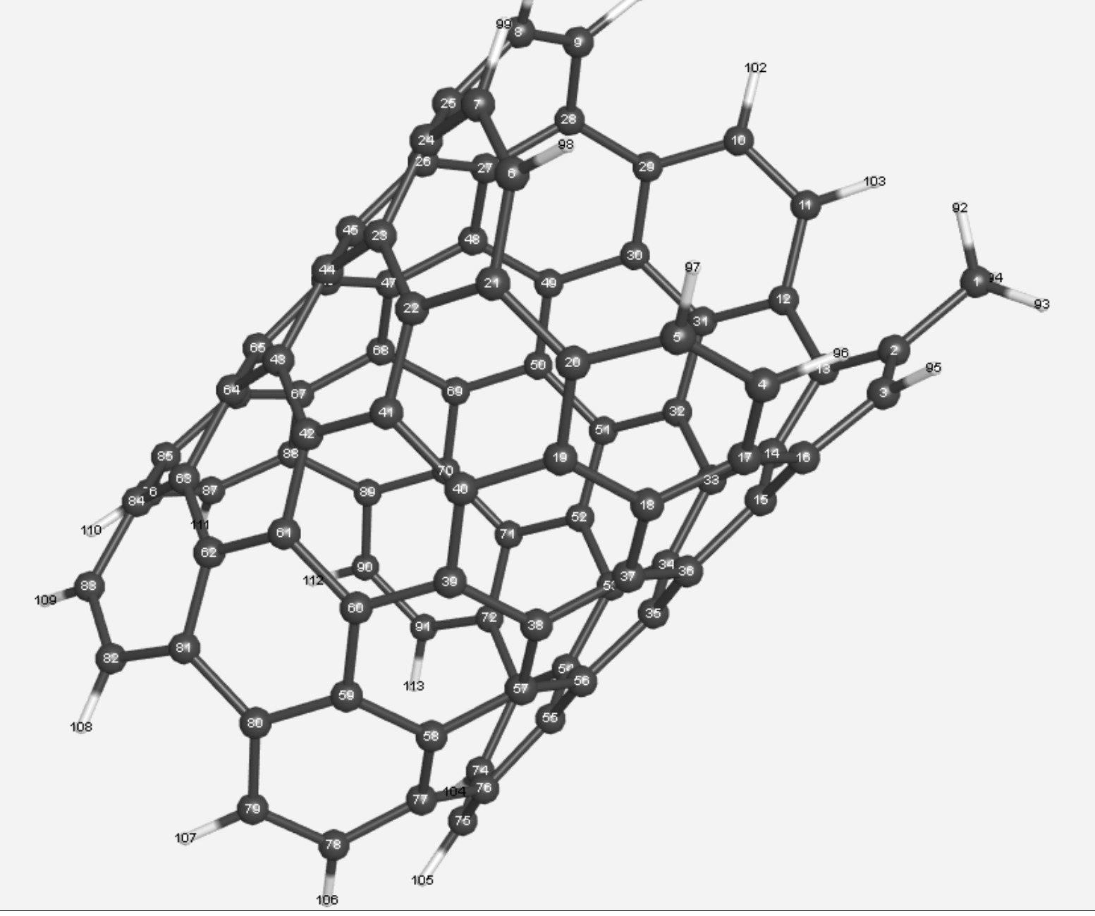

Energy = -3476.949503791730 Hartrees

Optimized Transition State:

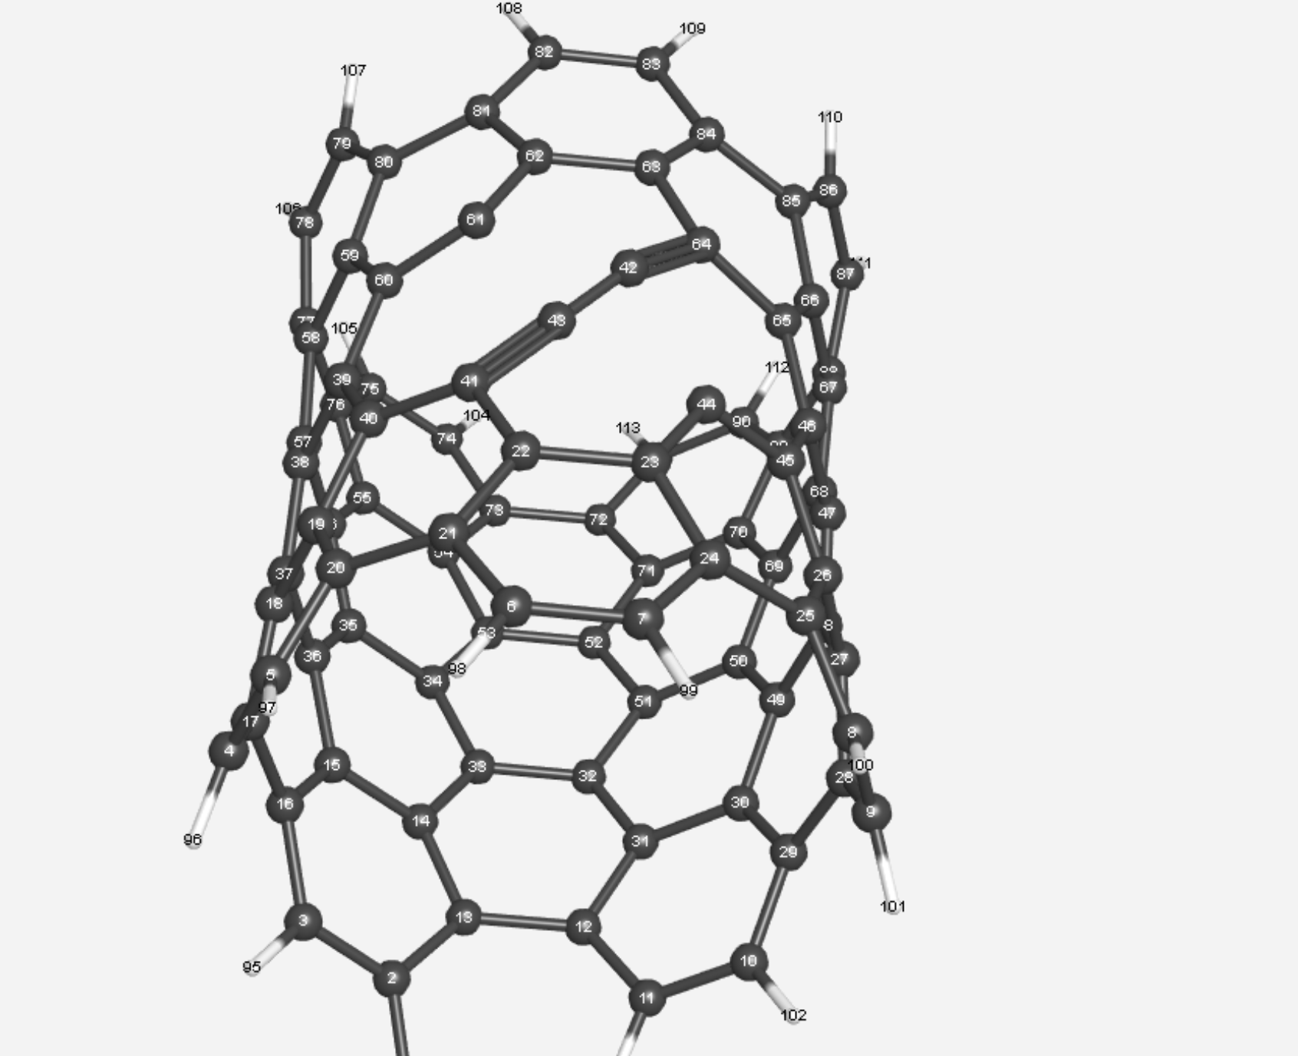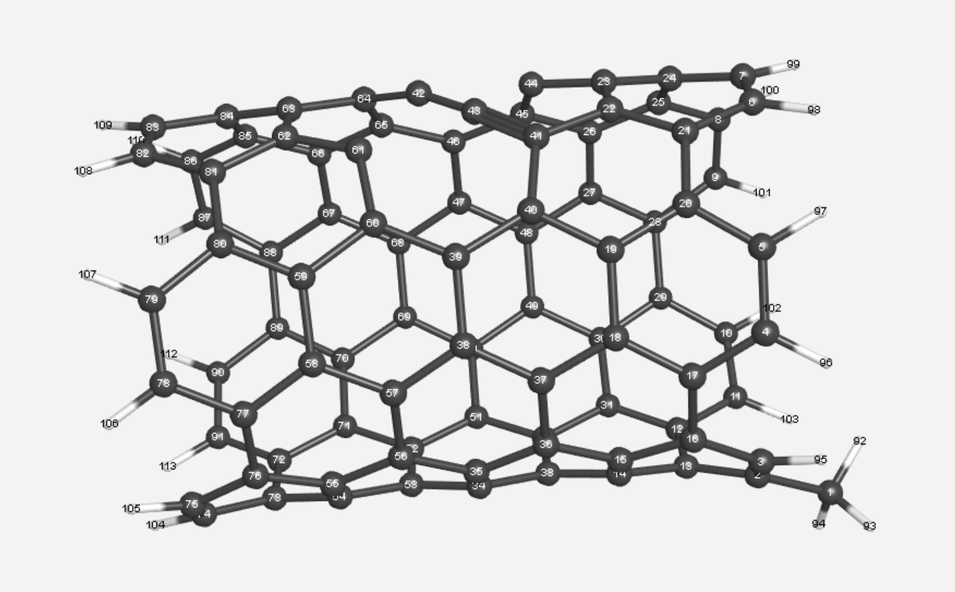

Energy = -3476.632155118699 Hartrees

ΔE=0.317348 Hartrees = 8.6 eV

(Compare to 8.52 eV for graphene, 7.98 eV for a 8,0 CNT, 8.39 eV for a 10,0 CNT)

Overlay:

